
The Mt. Gilead Messenger
The quarterly newsletter of First UMC and Zion UMC
November/December 2025

Church Family,
Every week I am reminded what a gift it is to belong to this loving, prayerful, and generous congregation. Whether we're worshiping together, sharing a meal, supporting our schools, or checking on a neighbor, I see the Spirit at work through you. We are a church who shows up...not only on Sunday mornings, but in the everyday moments where grace meets real life.
In recent weeks, we’ve walked with Zacchaeus...a man who climbed a tree searching, curious, unsure, yet open. And when Jesus called his name, everything changed. Grace didn’t wait for him to have everything figured out...grace met him right where he was and led him forward. His life...and his house...were transformed because he had the courage to come down, listen, and take a faithful next step.
That same spirit is guiding us as we discern our next steps with Sacred Grounds & Sundry Center. ☕This is a new shop we are planning to possibly open in the former Speckled Paw location. We are proceeding thoughtfully and prayerfully...not rushing, not assuming, not moving on emotion alone. A faithful group of business and community-minded leaders are asking hard questions, exploring details, and...just as importantly...uncovering solutions. We want to be wise stewards. We want to build something that strengthens our community, honors God, and has a healthy foundation for long-term ministry. This is not simply about coffee...it is about connection, compassion, and community presence. Just like Zacchaeus, we are listening for Jesus’ call and coming down from the tree step by step...ready to receive grace and ready to respond.
There is much to be excited about in our church...and much to prepare for. We continue to grow deeper in discipleship, wider in welcome, and steadier in our mission. Our work ahead is not just about programs...it is about purpose. It's about vision. It's about becoming more and more the church God is calling us to be...a church where people are seen, known, and loved, and where Christ’s presence spills out beyond our walls.
Thank you for your prayers, your patience, your questions, and your faithfulness as we seek God's leading together. May we continue to walk forward with open hearts, curious spirits, steady courage, and the willingness to say...just like Zacchaeus... “Yes, Lord. Come to this house today.”
With gratitude and hope,
Pastor Michael Williams
Cell: 252.339.5017 Email: mwilliams@nccumc.org
Office Hours: M-Th, 8:00am-12:00noon Phone: 910.439.6475
Email: firstumcmtgilead@gmaill.com
First and Zion website: https://www.umcmtgilead.com
Find us on Facebook!
www.facebook.com/First-United-Methodist-Church-Mt-Gilead-NC-135881489769094

Weekly Bible Study

Pastor Michael has a weekly study on Wednesdays at 10 am at the Trilogy Bookstore on Main St. It is a study that uses The Wired Word™ to look at current events and relates them back to scripture. The group has been growing every week. Come join the discussion and grab a coffee or tasty treat while you are there.

Zion Sunday Worship
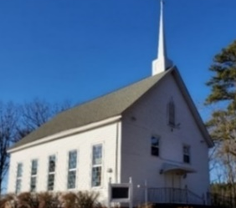
Zion Services begin at 9 am every Sunday morning. Zion also broadcasts the Sunday services via Facebook Live every week. Type the address below in your internet browser to go to the Facebook page and hit the follow button and you will be alerted every time the Church begins a live service.
https://www.facebook.com/Zion-UMC-102359131221555/?ref=page_internal

Ladies Exercise
The Ladies exercise group meets every Tuesday and Thursday from 9-10am. Anyone is welcome to attend. No experience needed. Come and join them! The ladies do not exercise on Thanksgiving Day.

United Methodist Men
The Methodist Men next meeting will be November 16th at 7:30am. Come join them for Breakfast and Business.

Children’s Message
While there aren’t kids every Sunday at First UMC, we would still like to always have a children’s message ready for the kids. We need more people to volunteer to have a short message prepared and ready to go if there are Children present. If you feel led to help with this, please reach out to Rev. Michael or Taryn in the office.

United Methodist Women of Faith
The United Methodist Women of Faith will hold their next meeting December 4th at 10 am. The meeting will be in the Fellowship Hall. At the meeting they will hold their 3rd Annual Cookie Exchange and Christmas Bingo! Come join them.
Please Remember that the Shoeboxes are due back into the church by November 16th.
If any of the ladies (or men) of the church would like to make some extra desserts for Feeding Loves’ event on Thanksgiving Day, it would be much appreciated!


Sunday School at FUMC
Please join us for Adult Sunday School at 9:45 am on Sundays. Currently all Sunday School classes are combined and are meeting in the Minnie Frutchey Classroom. We would love to see you there!

Chancel Choir/ Bell Choir


The Handbell Choir practices on Wednesdays at 5:30 pm in the Sanctuary.
Chancel Choir practice is on Wednesdays at 6:30pm.
Feeding Love
God’s love is reaching others through the help and encouragement of the Feeding Love ministry. What once started as serving around 30 people each time has turned into serving around 100-150 people on average.
The next event will be Thanksgiving Day- November 27th from 11:30-1:30.
You are invited to come and eat free food and to build up the community of faith with your prayers and enjoy Christian fellowship with one another. If you know someone who needs food, but can’t get to the event, you may take carryout plates to them.
If you are interested in feeding people with good food and with God’s unconditional love, please contact Henry Antos. Donations are welcome.
The Inasmuch Ministry hopes and prays to continue to reach more people in our community and beyond. Please continue to invite anyone you know that may benefit from this ministry.

Dessert Donations Needed
If you aren’t able to come and help on Feeding Love days, but still want to help, Henry has asked if the congregation can help with dessert donations each month. The cost of the desserts continue to increase through his food supplier and regular donations by anyone able would help drastically offset his costs each month.
He especially will need donations of desserts on Thanksgiving day. If you are able to make desserts for that day, please bring them to the church on Wednesday, November 26 or before Feeding Love begins at 11:30 on Thanksgiving Day.

Altar Flowers

Chancel flowers: The 2025 Flower Calendar is on the board for your attention! Don’t forget to sign up before your date has been taken. The calendar for 2026 will be going up soon! Start planning now.
Ecumenical Thanksgiving Service
There will be a Community Thanksgiving Service on Sunday, November 23rd at 6pm at First UMC. Anyone is invited to attend.
Prayer Concerns
Please remember all our loved ones that are sick, recovering, bereaved, and in a nursing home or assisted living with your prayers and cards.
Remember our nursing home and assisted living residents:
Elsie Harwood Marietta Andrews
Those that need continued prayer, in the hospital, ill or recovering:

Noah Allison Bob Lowdermilk
Ann Andrews Darlene McBride
Saron Baldwin Bill McLean
Ann Bates Nicholas Morris
Chris Baxley Abby Powers
Kenna Feis Billy Robinson
Pat Greene Jake Rodgers
Laura Haywood Jane Rushing
Phil Harris John Savino
Jim Harris Lavon Taylor
Nira Heyer Larry Thompson
Betty Ingram Brian Weddington
Noi Jon Whitney

Honorarium/Memorial Gifts
Gifts were given to FUMC in memory of:
- Don Oliver by Jack & Sue Jordan, Jim & Kate Evans
- Betty Oliver by Jack & Sue Jordan, Jim & Kate Evans
- Jimmy Deaton by Jack & Sue Jordan
Poinsettias
If you would like to place a poinsettia in FUMC in honor of or in memory of a loved one, there will be inserts in the bulletin each Sunday leading up to Advent. The cost of the poinsettias are $12 each. Please fill out the form and turn it into the church office or the offering plate. Forms need to be into the church by Tuesday, November 25th.
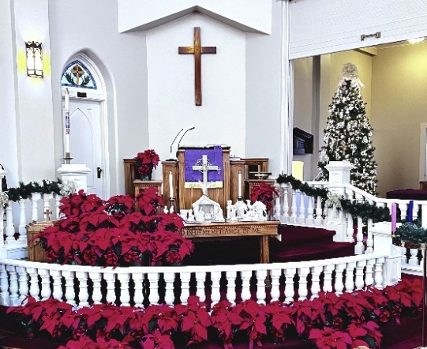
Potential Church Ministry Coffee Shop
We Need You! — Become a Sacred Grounds Steward
The community needs Christ’s warmth and love — and we’ve got the perfect place to serve it:
☕Sacred Grounds & Sundry Center, the coffee shop ministry we’re prayerfully working to reopen in the space once known as The Speckled Paw.
Would you consider being a Sacred Grounds Steward as we move toward making this vision a reality?
We’re looking for folks who can:
Help keep the shop tidy and welcoming
Wipe tables, sweep a little, restock cups and creamers
And most importantly — bring a cheerful spirit and friendly conversation! ☕
Offer a smile, a kind word, and help make every guest feel at home
You’ll always serve alongside our Store Manager or barista, so you’re never on your own.
Each shift is light, simple, and flexible — about 2-4 hours — and you’ll be part of a small team helping us keep the space warm, hospitable, and running smoothly.
This ministry is about more than coffee — it’s about connection, kindness, and community.
We have a few important steps ahead, and a wonderful team already asking the right questions to help us get there. But we can’t do it without you.
☕ Interested? Speak with Pastor Michael directly.
A sign-up sheet is located on the Bell table.
And please invite your family, friends, and neighbors to join us in this exciting new movement of love and hospitality.
Together, we can make Sacred Grounds a place where the community encounters Christ — one cup, one smile, and one conversation at a time.

Fellowship Hall usage
Please be reminded that if the Fellowship Hall is used by members of the church or by civic groups or others, tables and chairs should be put back up upon leaving. Trash cans also need to be emptied, and a new liner placed in the can. This ensures that everyone is able to use the space without having to clean up after the last group used the room.

Christmas Eve Services
Zion will hold their Christmas Eve Service at 4:30 on Wednesday, December 24th at Zion UMC.
First UMC will hold their Christmas Eve service on Wednesday, December 24th at 6pm in the Sanctuary.

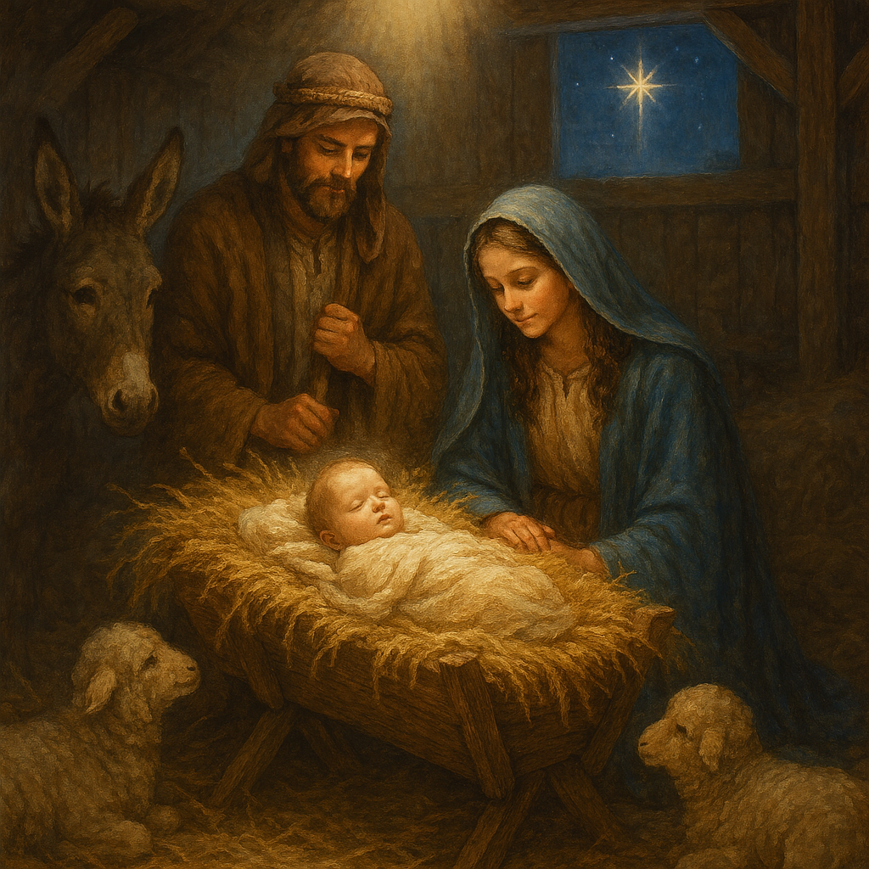

 | ~November 2025~
Sun | Mon | Tue | Wed | Thu | Fri | Sat
*All items in red are birthdays/anniversaries |  |  |  |  |  | 1  7:30 am- Food Pantry-  Mohawk Industries  Nancy Switzer
2 21st Sunday after Pentecost  9am – Facebook Live/in-person worship at Zion (Holy Communion)  9:45am- Sunday School @ FUMC  11am – Facebook Live/in-person worship at First (Holy Communion) | 3 | 4  9-10am- Seniors Exercise | 5  10am- The Wired Word™ @ Trilogy Bookstore | 6  9-10am- Seniors Exercise  Fellowship Hall reserved 5pm | 7 | 8  7:30am-Food Pantry-  Woodrun  Mitch & Sandy Taylor
9 22nd Sunday after Pentecost  9am – Facebook Live/in-person worship at Zion  9:45am- Sunday School @ FUMC  11am – Facebook Live/in-person worship at First | 10 | 11  9-10am- Seniors Exercise  Sarah Price | 12  10am- The Wired Word™ @ Trilogy Bookstore | 13  9-10am- Seniors Exercise | 14 | 15  7:30am- Food Pantry- Calvary Baptist
16 23rd Sunday after Pentecost  7:30am- UMM Breakfast Meeting  9am – Facebook Live/in-person worship at Zion  9:45am- Sunday School @ FUMC  11am – Facebook Live/in-person worship at First | 17  Paul & Sophia Chandley  Jack Dove | 18  9-10am- Seniors Exercise | 19  10am- The Wired Word™ @ Trilogy Bookstore | 20  9-10am- Seniors Exercise | 21 | 22  7:30 am- Food Pantry- First Presbyterian Church  Jim Evans
23 Christ the King Sunday  9am – Facebook Live/in-person worship at Zion  9:45am- Sunday School @ FUMC  11am – Facebook Live/in-person worship at First  6pm- Thanksgiving service at FUMC | 24  Jodi Kiser | 25  Last day to order poinsettias   | 26  10am- The Wired Word™ @ Trilogy Bookstore | 27 Office Closed for  Thanksgiving  11:30-1:30 Feeding Love  Don Burris  Perry Andrews | 28  Ron & Kathryn Kincaid | 29  7:30 am- Food Pantry- Gilmont Service Club  Peggy Evans  Pat McRae
30 1st Sunday of Advent
9am – Facebook Live/in-person worship at Zion
9:45am- Sunday School @ FUMC
11am – Facebook Live/in-person worship at First

 | ~December 2025~
Sun | Mon | Tue | Wed | Thu | Fri | Sat
*All items in red are birthdays/anniversaries | 1  Rachel Speight | 2  9-10am- Seniors Exercise  Bill Short | 3  10am- The Wired Word™ @ Trilogy Bookstore  Nancy Brandenburg  Cathy Johnson  Brian Tilley | 4  9-10am- Seniors Exercise  UMW- Christmas Cookie & Bingo Exchange 10 am | 5 | 6  7:30 am- Food Pantry-  First UMC  Fellowship Hall reserved  Chip Miller
7 2nd Sunday of Advent  9am – Facebook Live/in-person worship at Zion (Holy Communion)  9:45am- Sunday School @ FUMC  11am – Facebook Live/in-person worship at First (Holy Communion) | 8  Gail Robinson | 9  9-10am- Seniors Exercise | 10  10am- The Wired Word™ @ Trilogy Bookstore  Mark Brandenburg | 11  9-10am- Seniors Exercise  Sue Jordan  Julia Blake | 12 | 13  7:30am-Food Pantry-  Woodrun
14 3rd Sunday of Advent  9am – Facebook Live/in-person worship at Zion  9:45am- Sunday School @ FUMC  11am – Facebook Live/in-person worship at First | 15 | 16  9-10am- Seniors Exercise | 17  10am- The Wired Word™ @ Trilogy Bookstore | 18  9-10am- Seniors Exercise  Emily Patillo | 19  Dan & Ellen Jones | 20  7:30am- Food Pantry- Calvary Baptist  Rebecca Pittman
21 4th Sunday of Advent  7:30am- UMM Breakfast Meeting  9am – Facebook Live/in-person worship at Zion  9:45am- Sunday School @ FUMC  11am – Facebook Live/in-person worship at First  Fellowship Hall reserved  Ron Kincaid Dan Peterson Motsy Hill | 22  Rodney & Lanna McRae | 23 | 24  4:30 pm Christmas Eve Service @ Zion  6pm Christmas Eve Service @ FUMC  Gil Haywood | 25 Office Closed  Christmas Day | 26  Ann Bates  Sandy Treece | 27  7:30 am- Food Pantry- Lake Tillery Church
28 1st Sunday after Christmas  9am – Facebook Live/in-person worship at Zion  9:45am- Sunday School @ FUMC  11am – Facebook Live/in-person worship at First  Greg Fritts Laura Haywood | 29 | 30  9-10am- Seniors Exercise  Chuck & Susie Routh | 31  10am- The Wired Word™ @ Trilogy Bookstore

FUMC Church Assistance for November/December

Date | Adult SS Teacher | Liturgist | Ushers | Children's Sermon | Open/Close
Nov 2, 2025 | Mitch Taylor | John Stilwell | Cathy Poole & Lee Ann Efird |  | Gil Haywood
Nov 9, 2025 | Jim Kiser | Millie Bruton | Cathy Poole & Lee Ann Efird | Jackie Jahns | Gil Haywood
Nov 16, 2025 | Alan Williams | Jackie Jahns | Cathy Poole & Lee Ann Efird | Lee Ann Efird | Gil Haywood
Nov 23, 2025 | Jodi Kiser | Cathy Poole | Jack Dove & Lee Ann Efird | Michael Williams | Gil Haywood
Nov 30, 2025 | Emily Patillo | Jen Williams | Cathy Poole & Lee Ann Efird | Anne Evans | Gil Haywood

Dec 7, 2025 | Mitch Taylor | Mitch Taylor | Bruce & Anne Evans | Jackie Jahns | Bruce & Anne Evans
Dec 14, 2025 | Jim Kiser | John Stilwell | Bruce & Anne Evans |  | Bruce & Anne Evans
Dec 21, 2025 | Alan Williams | Millie Bruton | Bruce & Anne Evans | Michael Williams | Bruce & Anne Evans
Dec 28, 2025 | Jodi Kiser | Jackie Jahns | Bruce & Anne Evans | Anne Evans | Bruce & Anne Evans


Hold your smart phone’s camera above the QR code to the right and a message will pop-up asking you to go to the website.
Don’t worry if you don’t know what a QR code is, you can always just type www.umcmtgilead.com in your search bar and it will take you straight to the website!

